Little Flower Parish has the distinction of being the first parish in the state of Ohio to introduce the ACTS parish based retreat. More than a simple retreat “program”, ACTS is designed to implement the New Evangelization in a way that transforms parishes into intentional disciples. Through a weekend retreat (men’s and women’s) and through small faith communities, parishioners are led to live their faith more intentionally on a personal and community level. Founded in San Antonio, TX in 1987, ACTS is now a national and international movement.
Little Flower Parish ACTS Retreats – 2014
Men’s Retreat: November 20-23, 2014 (begins on Thursday evening and ends early Sunday afternoon)
Women’s Retreat: May 14-17, 2015 (begins on Thursday evening and ends early Sunday afternoon)
Application forms are available in the Parish Office.
ACTS Missions Vision
Through the ACTS retreat, ACTS Missions provides the spark that ignites Catholics, worldwide, with the true eternal flame of the Holy Spirit. As an instrument of God, ACTS is the light that will bring about the New Evangelization to the entire world by fostering love and true discipleship, leading others to a commitment and obedience to Our Lord Jesus Christ by our every word, action and thought.
www.actsmission.org

“Holiness consists simply in doing God’s will, and being just what God wants us to be.” St. Thérèse of Lisieux

Frequently Asked Questions....
- How long does the retreat last?
The retreat begins on Thursday evening and ends after the 11:00 a.m. Mass on Sunday.

- Where is the retreat held?
The ACTS retreat for Little Flower Parish will be held at the Weber Center in Adrian, MI. Transportation to and from the retreat is provided.

- Is there a cost?
The cost of the retreat is $225.00. Anyone needing financial assistance can apply for a scholarship to help cover the cost.

- Is ACTS only for Catholics?
Non-Catholics who are exploring the Catholic faith are welcome to make the ACTS retreat.

- Must I be a parishioner at Little Flower Parish to make the ACTS retreat?
Preference will be given to parishioners, but if there are openings in the final weeks prior to the retreat, others will be welcome to apply.

Do you feel called to:

- Deepen your personal relationship with Jesus Christ?
- Find new ways to be meaningfully engaged in parish life?
- Connect with others on a deeper level in prayer and support?
- Share with others the amazing works God has done in your life?
If so, ACTS is for you!
ACTS is ...
- a parish-based retreat
- an opportunity to renew your spirituality, to strengthen your faith and its application in your daily life, and to build lasting friendships.
- about nurturing a community of intentional disciples.
- structured on the foundation of Adoration, Community, Theology and Service.
- an opportunity to experience how our daily lives are fundamentally impacted by the Word and Sacraments of our faith.

And... What is everyone saying about it?
- I came back from ACT’s with a renewed feeling about prayer. I find that I pray more often and it is a more central part of me and my day.

- The women that attended ACTS with me have become a close circle even if they live far away. I know that I have others praying for me as I pray for them. That is so reassuring to me.

- "A.C.T.S is more than a retreat; it is a renewal of faith. It is a building of a new family of sisters and brothers who want to share their journey with God and bring others to their walk of love. A.C.T.S brothers and sisters can be found where you least expect them."

- The ACTS retreat allowed me to see that I have special gifts, that I can make a difference, that I can feel I am worthwhile, and that I have so much that I can give to others. Isn’t that what God asks of us?

- I love attending a good retreat and ACTS is surely one of the best I have had the opportunity to attend. Not only did I receive the grace of a closer relationship with the Holy Trinity, I also learned so much about my FAITH and MYSELF.

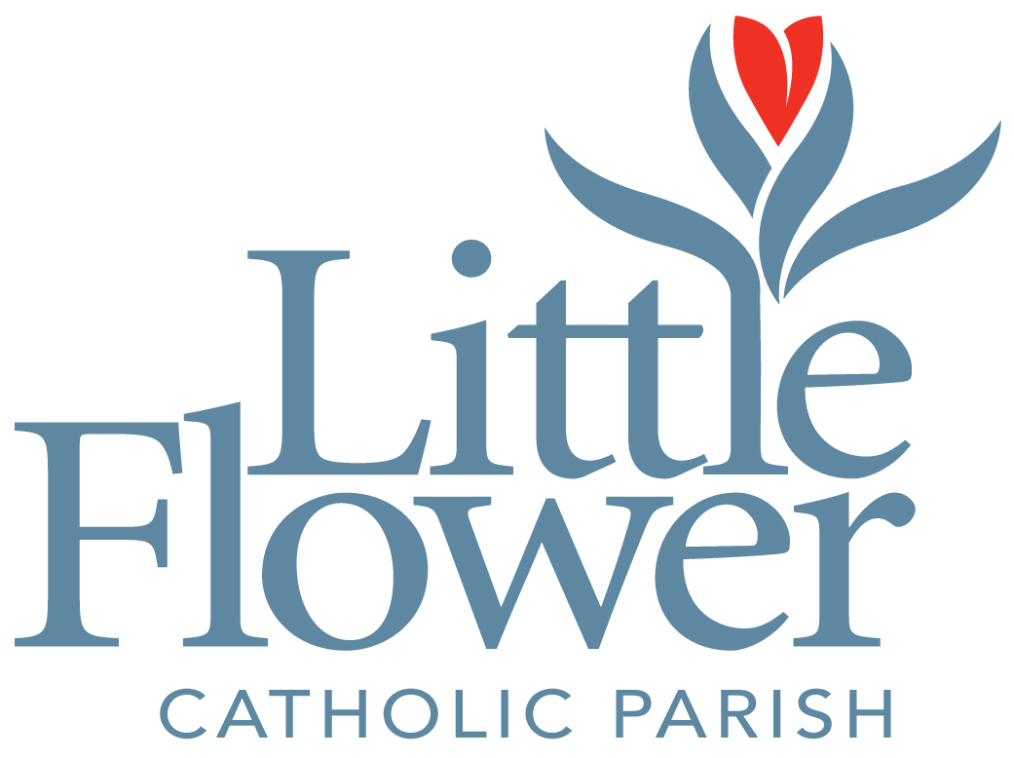
www.littleflowertoledo.org
What is ACTS?
Adoration
Community
Theology
Service
- A parish based retreat
leading to a life
of intentional discipleship...

