ACTS at Little Flower Catholic Parish

…ACTS is a time that you deserve for yourself". The weekend will not disappoint you or feel like a waste of your time. We give our time to so many others and activities, but giving this time to yourself will give you something unexpected.

…We both found it to be a heartwarming and spiritual experience!

…I came back from ACT’s with a renewed feeling about prayer. I find that I pray more often and it is a more central part of me and my day.

…The women that attended ACTS with me have become a close circle even if they live far away. I know that I have others praying for me as I pray for them. That is so reassuring to me.

…The ACTS retreat allowed me to see that I have special gifts, that I can make a difference, that I can feel I am worthwhile and that I have so much that I can give to others. Isn’t that what God asks of us?

…I love attending a good retreat and ACTS is surely one of the best I have had the opportunity to attend. Not only did I receive the grace of a closer relationship with the Holy Trinity, I also learned so much about my FAITH and MYSELF.

…ACTS is more than a retreat; it is a renewal of faith. It is a building of a new family of sisters and brothers who want to share their journey with God and bring others to their walk of love. ACTS brothers and sisters can be found where you least expect them.

www.littleflowertoledo.org

What is… ACTS?

Adoration
Community
Theology
Service
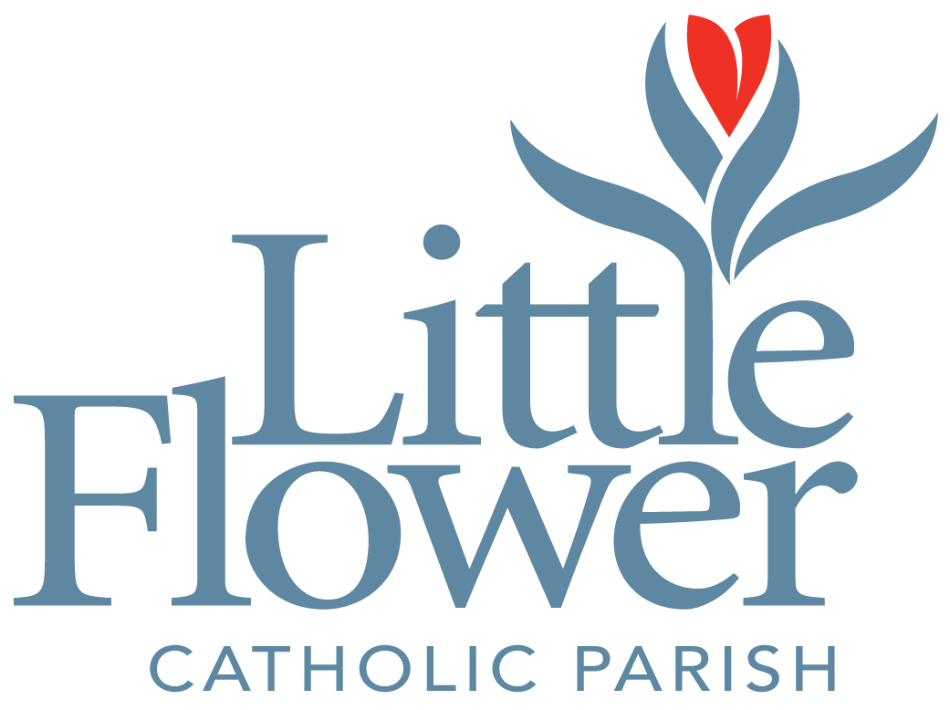

Women’s Retreat: April 24-27, 2014

And… What is Everyone
Saying About It?

Turn the pages to find out more about Little Flower ACTS Retreats…

Little Flower Women’s ACTS Retreat
Weber Retreat Center, Adrian, MI

ACTS Retreat Registration April 24-27, 2014

Little Flower Parish is now accepting applications for the Spring 2014 ACTS retreat weekend for women. This parish-based retreat offers the opportunity to renew your spirituality, to strengthen your faith and its application in your daily life, and to build lasting friendships. It is presented by your fellow parishioners.

The retreat begins Thursday evening, April 24, with check-in at
6:00 pm at Little Flower Church. Transportation will be provided to and from the retreat center in Adrian, MI. The retreat concludes at the 11:00 am Mass on Sunday (Little Flower), with a reception following. Approximately 7-10 days prior to the retreat, you will receive a letter describing what to bring with you (clothing, reading material, etc.) for the weekend.

The cost of the retreat is $225.00. A deposit of $75.00 is requested to reserve your place, and the remaining balance ($150) is to be paid Thursday evening at the beginning of the retreat. Please send your completed registration form, along with the deposit to:
Little Flower Parish
Attn. Sr. Marilyn Marie
5522 Dorr Street *Make checks payable to
Toledo, OH 43615 Little Flower Parish.

PLEASE NOTE: Financial difficulties should not prevent anyone from attending this retreat. If you wish to inquire about a scholarship or need more info, please contact:
- Sr. Marilyn Marie
419.537.6655
- Fr. Dave Nuss
419.537.6655

Your Name: _____________________________________________

Parish: __________________________________________________

Name as you want it to appear on your name tag: ________________

Address: ________________________________________________

City: ________________________ Zip: ________________

Home Phone: _________________ Work/Other Phone: __________

Your E-mail address: _______________________________________

Emergency Contact #1: _____________________________________

Relationship: _____________________________________________

#1 Phone: ______________ #1 Emergency Contact’s Cell: _________

Emergency Contact #2: _____________________________________

Relationship: _____________________________________________

#2 Phone: ______________ #2 Emergency Contact’s Cell: _________

Any special physical, dietary, medical or other needs for the retreat weekend: ________________________________________________

________________________________________________________

________________________________________________________

